
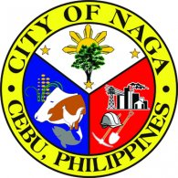
Republic of the Philippines
Province of @prov
@mun
Rural Health Unit
DEATH CERTIFICATE
@head
City Health Officer
@mun, @prov
This is to certify that @cadavename died last @dded at @diedat.
This certification is being issued upon the request of @reqby for the issuance of Death Certificate.
Done this @day day of @month @year at RHU - @mun, @prov.
 |  | @1head
 |  | Rural Health Midwife
Amt Fee: | @amount
OR No.: | @orno
Date: | @datepaid
@mun, @prov, Philippines

